|  |  |  |
| --- | --- | --- |
| **Problem Chosen** C | **2022 MCM/ICM Summary Sheet** | **Team Control Number** 2208251 |

**The Trading Strategies Based on Machine Learning**

**Summary**

With the continuous update of machine learning algorithms and computing power, machine learning is becoming more and more important in the formulation of trading strategies.

This paper aims to develop a model that gives the best daily trading strategy including quantitative timing, portfolio allocation of assets based only on price data of bitcoins and gold up to that day.

In response to the above problems, we first extracted the 4-character characteristics including MACD, HV, RSI, BOLL of the above two types of assets based on financial market knowledge.

Through training past data in random forest classification model, we predict a series of important decision points and summary some timing strategy.

In order to minimize risks and maximize benefits, we established a multivariate programming model based on Marwiz model. To predict the parameters of model, we build a two-layer 260-layer 30-steps RNN-GRU model.

Through the above methods, our trading model finally achieves annual returns of and finally get $3382 through the 5-year best strategy trade. To derive models’ generality, we simulate 100 curves for bitcoins and gold each through geometric Brownian motion and the value of the best decision benefit is always stable at about $3580.

In the end, in order to test the sensitivity of the model, we adjusted the transaction coefficient and found that the final transaction value of our model was always relatively stable.

**The keyword：**Marwiz model, RNN-GRU model, Random Forest Classification model, Geometric Brownian Motion, Quantitative trading.

**Contents**

1 Introduction 3

1.1 Problem background 3

1.2 Restatement of the Problem 3

1.3 Our Work 4

2 Notations 4

3 Assumptions 5

4 量化择时模型 5

4.1 黄金闭市日处理 5

4.2 常见量化择时方法与特征指标提取 6

4.3 基于随机森林的决策点判定 10

5 资金配比模型（组合投资决策） 16

5.1基于GRU-RNN的未来指标预测 16

5.2以Markowitz思想为核心的多目标规划模型 17

6 交易策略模型性能最佳性评估 18

6.1 Geometric Brownian motion generates test data几何布朗运动生成测试数据 18

6.2模型性能检验 20

6.3针对不同时期的交易策略的优化 21

7 模型对交易成本的敏感程度分析Sensitivity Analysis 22

8 Strength and weakness 22

8.1 Strengths 22

8.2 Weakness 22

9 Conclusion 22

10 Document to the ICM Society（letter） 23

Reference 25

# Introduction

## Problem background

With the development of economy and the continuous improvement of financial market, the transaction of volatile assets has been popular among major companies. Banks, securities companies, professional trading companies and other companies spend a lot of money to recruit excellent market traders to invest in volatile assets for them in order to chase the dividends in volatile asset trading.

Market traders buy and sell volatile assets in order to achieve the maximum total return and generate profits for their companies. If traders misbehave, the company may suffer significant losses, so it is necessary for us to develop a model to determine whether traders should buy, hold or sell assets in their portfolios every day to help traders make trading reference, in order to expand the total return.

## Restatement of the Problem

In this problem, we were given two data sets, *BCHAIN-MKPRU* and *LBMA-GOLD*, and were asked to develop a model that used only the past daily trade price flows from the given two databases to date to determine whether traders should buy, hold, and sell assets in their portfolios on a daily basis.

On the basis of the above conditions, we mainly divided into the following three parts to solve the problem and optimize the model,

* **Develop a model that gives the best daily trading strategy.** We will use the original capital of $1000 to strictly execute the established trading strategy beginning November 9, 2016 and calculate the total amount of return from adopting our trading strategy for the five years ending September 1, 2021.
* Provide some model testing methods to **prove that our model is the best strategy.**
* **Considering the sensitivity of the model to transaction costs,** analyzed the influence of transaction costs on transaction strategy and total return volume**.**

At the end we will present our strategy, model and results to trader in a memorandum of two pages.

## 1.3 Our Work

Our quantitative trading model covers the whole process of quantitative trading, and our model can interact with traders to a certain extent. The overall model is shown in the figure below.

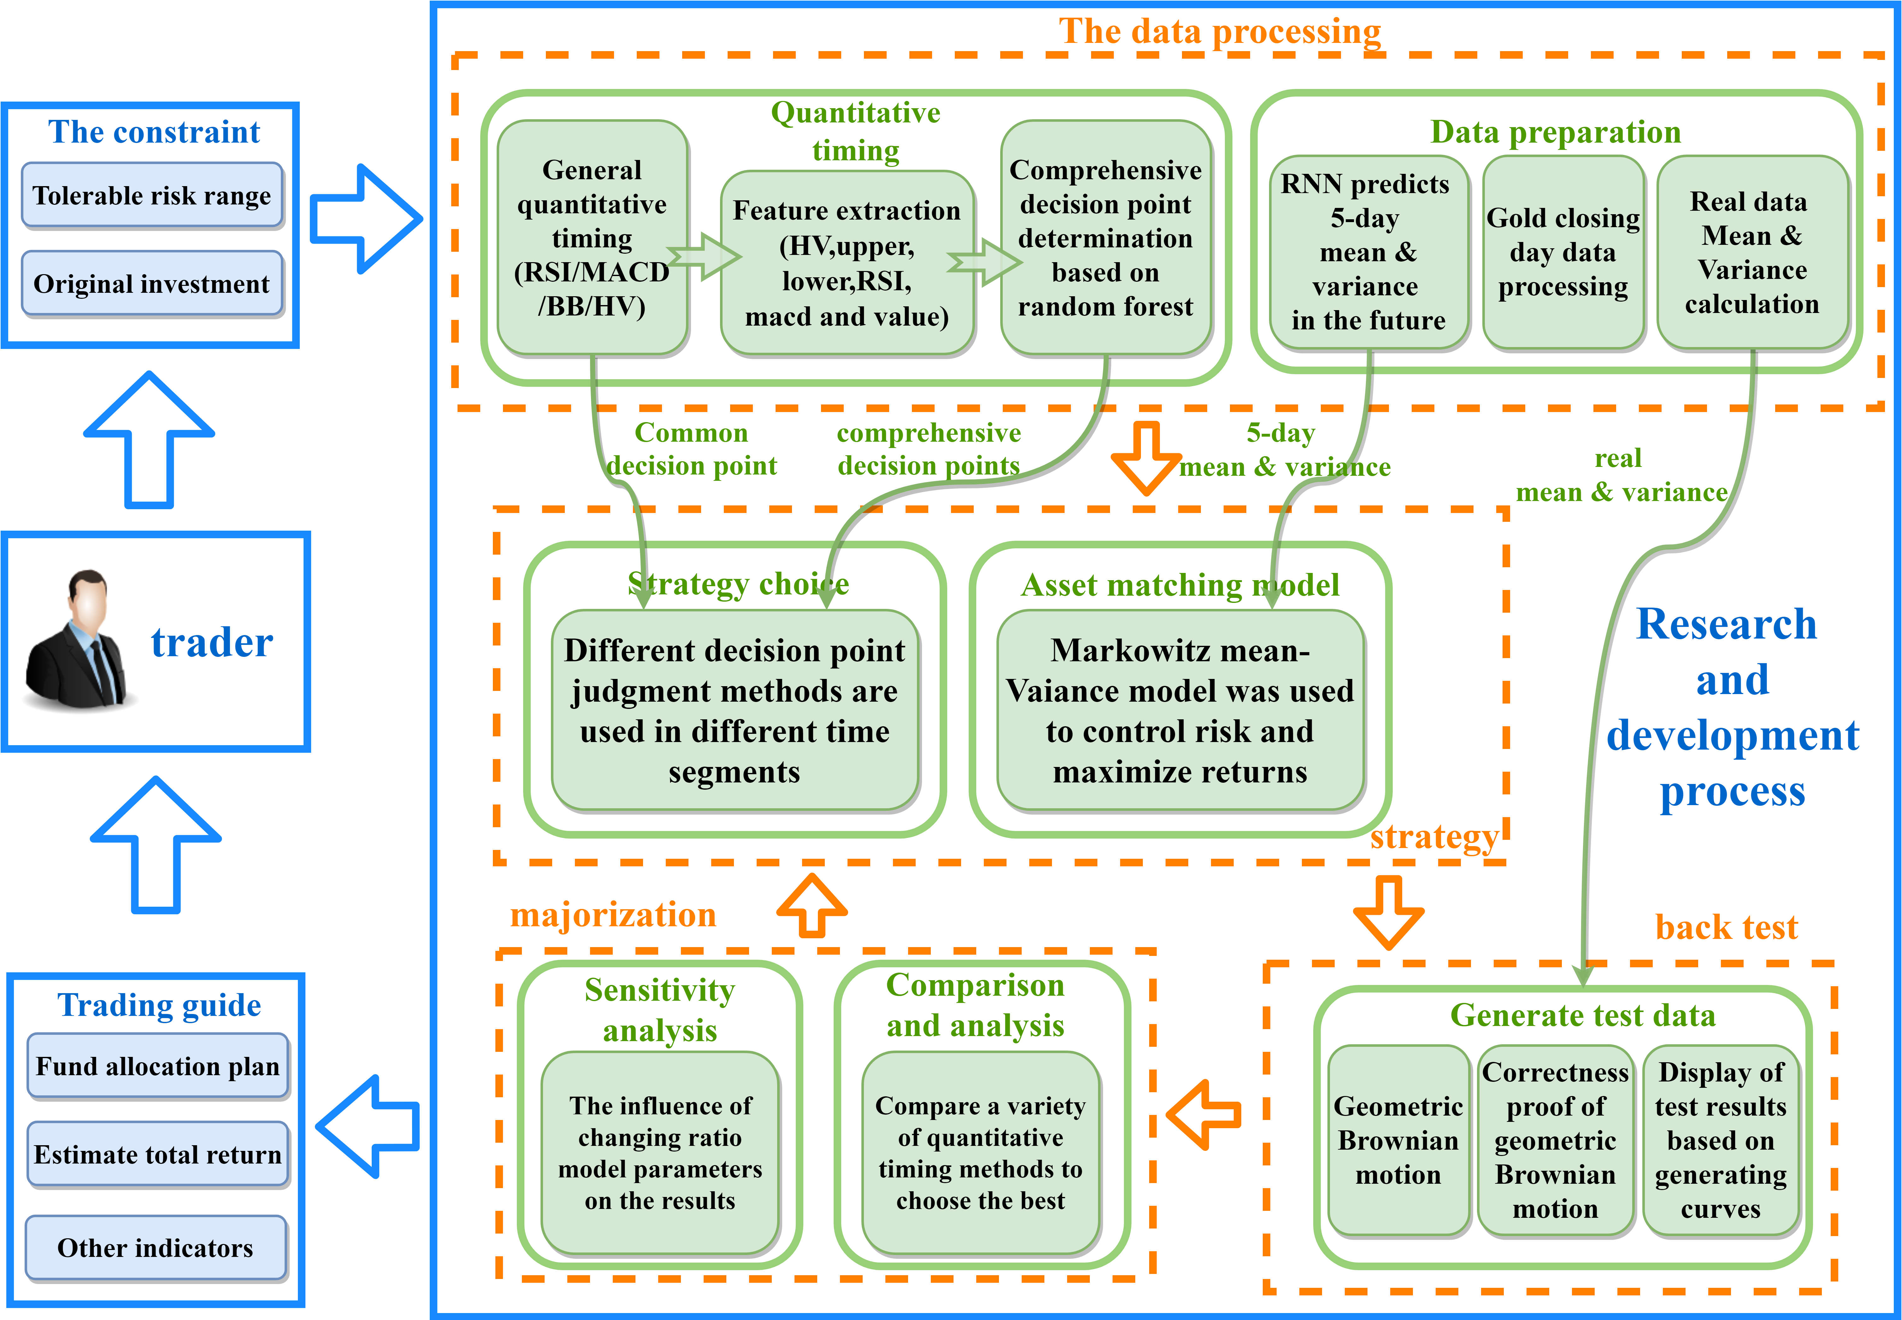

**Figure 1**：Work Flow

# Notations

The following symbols are common throughout the article,

**Table 1**：notation explanation

|  |  |
| --- | --- |
| **Symbols** | **Definitions** |
|  | The upper rail of the Boleyn belt |
|  | The lower rail of the Boleyn belt |
|  | Moving average convergence divergence |
|  | Historical Volatility |
|  | The closing price |

# Assumptions

Based on the understanding of the meaning of the questions and the convenience of follow-up work, we put forward several assumptions as follows.

* In gold and bitcoin trading, short-selling is not considered, and only going-long is used. In other words, we make money by buying at the current price and selling after the price of gold or bitcoin goes up, earning the difference. Basically, buy before you sell.
* Buying and selling something in dollars during our transaction. This is because we have a small initial investment and cannot buy the entire amount of gold or bitcoin at one time. Measuring gold and bitcoin in dollars makes it easier to calculate.
* Both gold and bitcoin are bought and sold for the day based on the day's closing price. And each type of product can only be bought or sold once a day.
* Consider the dollar's own rate of return, that is, uninvested dollars produce a risk-free rate of return, analogous to a bank's call rate.

# Quantitative timing model

## 4.1 Data processing of gold's closing day

Bitcoin is a virtual currency, while gold is an international currency, and the nature of both partly means that bitcoin can be traded on a daily basis, while gold is only traded on days when markets are open. Due to the absence of gold transaction data in some specific dates, for different calculations, the gold data set is processed by the following two methods，

* Delete: In risk assessment and calculation of various assessment indicators, we directly delete missing data to simplify analysis. Deleting missing data directly preserves the most authentic data features.
* Assignment: In buying and selling decisions, the lack of data may affect the consistency of gold and Bitcoin data structures, so we use the previous day's data for closed trading dates. The supplementary data is the same as the previous day. Based on the constraint conditions of the matching model established below, no gold trading can be conducted on the closing day of the gold market.

## 4.2 Common quantitative timing methods and feature index extraction

We summarized several commonly used quantitative timing methods as follows, and extracted some characteristic values from these methods.

* **Relative strength index(RSI)[1][2]**

The principle of the relative strength index (RSI) is to predict the strength of the market movement trend by calculating the range of price rise and fall, and then predict the continuation or reversal of the trend. It actually shows how much gold or Bitcoin prices have moved up as a percentage of the total volatility. The calculation formula of RSI is as follows，

The variable indicates average gains over the past *n* days, and the variable indicates average declines over the past *n* days.

According to the strength index theory, any market price rises or falls between 0 and 100. According to the normal distribution, RSI value is generally believed to change between 30 and 70. Usually, 80 or even 90 is considered as the market has reached the overbought state, and then the market price will naturally fall back to adjust. When a price falls below 30 it is considered oversold and the market will rebound. If the strength of RSI index is used to make buying and selling decisions, the decision points of buying and selling should comply with the provisions in the following table.

**Table 2**: RSI strength determines the trading principle

|  |  |  |
| --- | --- | --- |
| RSI | operation | Decision point judgment |
| 50-100 | Sell | 1 |
| 20-50 | Hold | 0 |
| 0-20 | Buy | 1 |

Where 1 represents the decision point and 0 represents not the decision point. Points with strong RSI values are set as sell points with high urgency to reduce risk and avoid a big drop. We plotted figure 2 using the RSI exponent,

**Figure 2:** RSI analysis of bitcoin's daily price in 2021

The generated and curves are 14-day RSI curve and 30-day RSI curve respectively. The cross signal of two RSI curves can also be used as a criterion to judge decision points. The judgment method of decision points based on cross signal amount is as follows:

**Table 3**: RSI cross signal buying and selling principle

|  |  |  |
| --- | --- | --- |
| Cross situation | operation | Decision point judgment |
| goes up through | Buy | 1 |
| Not cross | Hold | 0 |
| goes down through | Sell | 1 |

The combination of the two RSI curves is: goes up through , which belongs to the long market; If goes down through , it is a bear market.

Generally, RSI index has a certain reference function for the rise and fall of prices and traders' trading strategy planning, and the union of the above two decision points is taken when judging the decision points.

* **Bolliger bands (BB)[3]**

Bolliger bands (BB) are track bands with moving average as the middle line and the mean square error of closing price as the bandwidth. Parameters include two, namely, statistical days *m* and width (generally 2). The calculation formula of BB is as follows,

Where represents the m-day simple moving average of the closing price, UB represents the upper track, LB represents the lower track. Using each parameter, we can make the following figure 3,

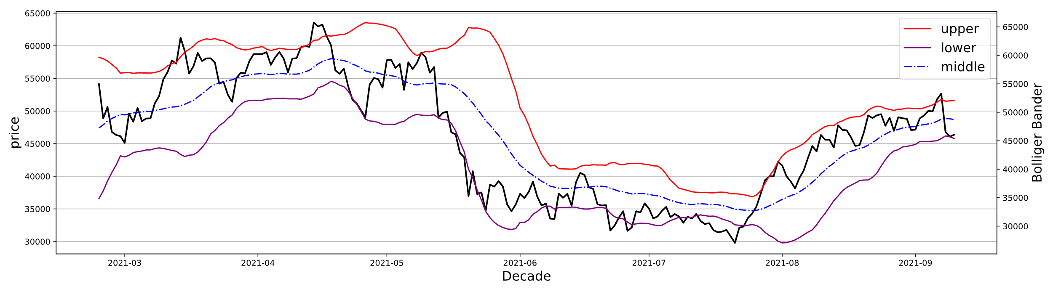

**Figure 3:** BB analysis of bitcoin's daily price in 2021

In this case, BB uses the wave band to display the safe high and low price of bitcoin, so as to determine the fluctuation range and future trend of bitcoin price. Our criteria for defining bollinger band buying and selling points are shown in the table 4 below，

**Table 4**: BB Summary of buying and selling principles

|  |  |  |
| --- | --- | --- |
| Bitcoin price trends | operation | Decision point judgment |
| Touch on the upper | Sell | 1 |
| Not touch | Hold | 0 |
| Touch the lower line | Buy | 1 |

To put it simply, BB's bid-ask judgment principle is to buy when the price of bitcoin touch on the upper and sell when the price touch the lower line.

* **Moving average convergence divergence(MACD)[4]**

MACD is a typical trend-based indicator used to judge the timing of buying and selling by analyzing the convergence and separation between the short-term (12-day term) and long-term (26-day term) moving averages based on the construction principle of averages.

The calculation of today's n-day exponential moving average is as follows,

Where represents the n-day exponential moving average of the previous day, and represents today's closing price.

The calculation of *DIF* is defined as follows,

Where is the short-term exponential moving average, and is the long-term exponential moving average. The *EMA* of 9 days is calculated according to the deviation value *DIF*, that is, the average deviation value, which is the *DEA* value of today. *DEA* is defined as follows,

Where is the *DEA* value of the previous day. The difference between the and its own moving average is *,* is defined as follows,

Take bitcoin as an example and calculate its for 2021. Finally, we draw a figure based on the calculated indicators,

**Figure 4:** MACD analysis of daily bitcoin prices in 2021

The bar chart in the figure is generated by index. From the above figure, we can more intuitively understand the buying and selling principle generated by MACD. That is, the moment when the bar chart changes color is the signal of market reversal, indicating that the overall trend of previous decline or rise basically ends, and asset allocation should be updated at this time. The trading principles are summarized in the table below.

**Table 5**: Summary of MACD trading principles

|  |  |  |
| --- | --- | --- |
| Histogram color characteristics | operation | Decision point judgment |
| Change from red to green | Buy | 1 |
| Not change | Hold | 0 |
| Change from green to red | Sell | 1 |

* **Historical Volatility(HV)**

Historical volatility (HV) refers to the volatility displayed by the market, which is reflected by the historical data of asset market prices over a period of time. Volatility can vividly reflect the volatility of the market. We assume that it is positively correlated with the risk of the market, and a volatile market usually means higher and faster gains or losses and higher risks. We use the following algorithm to calculate its 5-day historical volatility (N=5),

represents the closing price of day i, and ， represents the closing price of day i +1. Based on the above formula, we obtain the 5-day annualized historical volatility of gold , and the 5-day annualized historical volatility of Bitcoin , where 252 is the number of days in a year that gold can be traded, 365 is the number of days in a year that bitcoin can be traded。

## 4.3 Decision point determination based on random forest

We know that many trading systems or technical indicators are imperfect and can only be applied to specific market patterns. When they are applied to other markets, they may need to be matched by other indicators, or the parameters may need to be modified.

In response to these characteristics of technical indicators, successful investors can take the following two paths:

One way is to choose some of the most applicable indicators, repeated tests and even perfect, and then use it in the appropriate market or opportunity, using the very accurate several opportunities to profit, many trading masters are known for being good at using a few indicators;

Another way is to use multiple indicators comprehensively to verify each other.

In this paper, we choose to use random forest algorithm to comprehensively verify each other with a variety of indicators, so as to determine the decision point. Random forest is in line with the thinking logic of investors in actual investment, so the decision tree model has strong scalability. We can increase or decrease and change technical indicators to create personalized trading strategies.

Random forest is an ensemble learning algorithm, which combines several weak classifiers into one strong classifier. Random forest uses bootstrap to randomly extract samples from the training set, and selects random features for each decision tree on the basis of Bagging. The samples are used to build decision tree models. Finally, the decision tree model is used to vote to get the result. The specific algorithm steps[6] of random forest are as follows:

* Enter training set
* Bootstrap sampling was used to form *k* training subsets .
* We randomly extract m features from the original features.
* By training the training subset and making the optimal segmentation of randomly selected features, decision tree prediction results can be obtained.
* The result with the highest number of votes is obtained by voting according to prediction results.

We used a post-pruning algorithm to prune each original tree from the bottom up. The algorithm starts to prune at the bottom internal node. If the node is replaced with a leaf node to improve generalization performance, the subtree is replaced with a leaf node. Figure 6 shows a pruned decision tree,

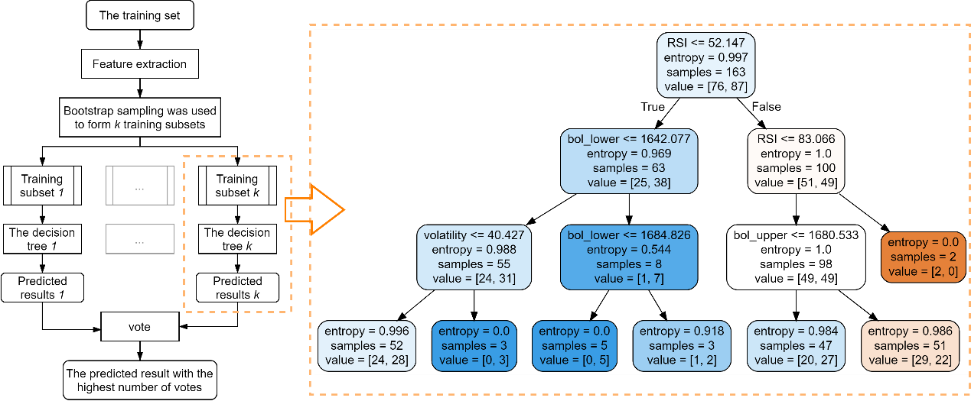**Figure 5:** Flow chart of random forest algorithm **Figure 6:** A pruned decision tree

According to the parameters of the decision tree, and , as well as the number of trees and the maximum number of features in the decision tree in the random forest, data were trained and the ranking results of feature importance were obtained as shown in Figure 7. It can be found that the parameter is of high importance in both gold and bitcoin markets.

**Figure 7:** Feature importance display

The decision points generated by random forest voting are shown as follows,

(a) Bitcoin

(b) Gold

**Figure 8:** Partial decision points of 2019 generated by random forest

From the figure 8, we can clearly see the distribution of buying and selling decision points of gold and bitcoin in 2019. Direct observation shows that most of the decision points are distributed near the market reversal point and the position of sharp rises and falls. In order to avoid severe losses caused by the collapse of gold and Bitcoin as much as possible, we decided to retain all the decision points generated by the random forest, that is, if there is a decision point in a date, whether it is from the gold decision point or from the bitcoin decision point, a round of asset ratio planning will be conducted.

In this section, we adopt Markowitz's concept of "maximizing returns. The concept of risk minimization is used to establish a multi-objective programming model to study the optimization of uncertain return and risk portfolio in portfolio investment decision making. Meanwhile, the price of the next month predicted by the section RNN network is used to evaluate the return and risk. This model examines the impact of asset risk, return, correlation and diversification on portfolio return.

* **Determination of objective function**

We define the asset holdings at decision point as: ：[], where represents cash holdings and the unit is U.S. dollars, represents gold holdings in ounces, represents bitcoin holdings in units. Asset value at decision point is defined as [], where is the price of U.S. dollars, which is always 1. represents the value of gold in US dollars per ounce. represents the value of a bitcoin in U.S. dollars. Therefore, the original portfolio value at time T of this decision point is , where:

Where  represents cash holdings before adjustment, represents gold holdings before adjustment, and  represents bitcoin holdings before adjustment. The commission costs of gold and Bitcoin transactions are respectively and of the transaction amount, so we can get the commission costs needed to adjust assets:

Where  represents the adjusted cash holdings, represents the adjusted gold holdings, and represents the adjusted bitcoin holdings. The expected value and of the next five days can be obtained from the prediction of gold and bitcoin by THE RNN network in the previous section. The objective function of maximizing the expected return of total assets in the next month can be obtained，

In addition, the festival has been using RNN network to predict the price of five days for the next five day price variance and covariance with gold and currency for the price of gold and currency covariance matrix, we used to mobilize after the value of the asset portfolio variance represents the future of investment risk, The objective function of risk minimization can be obtained:

is the variance of gold over the next five days, is the variance of Bitcoin over the next five days, and and · are the covariances of gold and Bitcoin prices over the next five days.

* **The constraint**

1. it is assumed previously that shorting is not allowed in asset allocation investment,

, , 0

2. The assets are reallocated at the decision point and the portfolio value at the decision point t is adjusted.

The portfolio value obtained after redistribution shall be equal to the sum of the portfolio value before allocation and the commission cost incurred in allocating the asset investment，

3. The gold trading market is closed on weekends and some holidays (Christmas and New Year’s Day), so when the decision point coincides with the closed date, we use the data preprocessing process to assign the closed gold price to the price of the previous day as the judgment benchmark，

()

4. Considering the psychological factors of investors themselves, general investors have a certain range of risk tolerance. Therefore, we improved the risk requirements of investors by changing the constraints in the multi-objective programming model.

Where， is the maximum risk threshold given by the customer

* **Integration of conditions and goals**

The multi-objective programming model for balancing benefits and risks is established as follows：

We take profit maximization as the first-level objective of optimization and risk minimization as the second-level objective. Multi-objective planning is carried out at decision points to reallocate asset holdings.

* **Demonstration of solution results of multi-objective programming model**

**Figure 9:** Trends in gold and dollar investment volumes

For five years trading assets value change with the gold, the currency of the relationship of the trend of prices we use double y axis will be the trend of drawing as shown above (the currency for the right y axis) alone, for the above changes the value of total assets and the actual price trends of comparative analysis, we preliminary analysis for the following:

1. In 2018, when the market trend was not good and volatility increased, the total asset value lost, but still controlled a certain loss rate

2. Bitcoin showed a continuous upward trend at the end of 2017 and 2020, and our model grasped the upward trend and ushered in a considerable return rate on the total asset value.

3. At the beginning of 2017, when the gold price curve fluctuated while the bitcoin value curve fluctuated little, the total asset value fell slightly, but it also showed a trend of steady rise.

(a)bitcoin

(b)gold

(c)doller

**Figure 10:** Asset ratio and price curve trend comparison diagram

In order to study how the objective planning model balances benefits and risks to make decisions, we also make comparative analysis of the three asset values with the price trends of gold and Bitcoin, and draw the following strategic conclusions:

1. Due to uncontrollable factors such as market disturbance the price of gold and currency, RNN five days of expectations and random forest prediction decision points still can not completely replace the future trend of the market, in 2018, the currency falling trend because of RNN forecast and actual price in contrast to distribute assets mainly to the currency, cause downward trend; In our optimization model, assets are transferred to gold to control a certain loss rate

2. When weighing and predicting the downturn of gold and bitcoin in the future or the high investment risk, our planning model will adopt the strategy of withdrawing all positions, especially in 2020 and 2021 when the price volatility of bitcoin and gold is high, this strategy will be frequently adopted.

3. The higher value intensity of bitcoin asset holdings in the figure corresponds to the rise in the price of total assets, because our optimization model grasped the rising trend while considering risk factors, thus achieving a considerable return rate on asset value.

Based on the above analysis, we established a better grasp of the trend of the model, has a certain stop loss ability and a good return,

The investment started from $1000 on November 9, 2016 to $3381.94 on November 9, 2021, achieving a good five-year average annualized return of 27.6%.

# Portfolio investment decision model组合投资决策

## 5.1 Index prediction based on GRU-RNN

Recurrent neural network (RNN)[7] is a special neural network structure, which is based on the idea that "human cognition is based on past experience and memory". It not only takes into account the input from the previous moment, but also gives the network a kind of 'memory' of the previous content. That is, the current output of a sequence is related to the previous output. Here, we use RNN to summarize the past experience and memory of gold and bitcoin in order to predict future market changes.

Based on the high volatility of gold and bitcoin market, it is easy to be affected by external environment, policy, economy and other factors. We introduce GRU gating model based on RNN network. GRU's update gate  and reset gate  prevent the memory from focusing too much on past features. Compared with LSTM model, GRU is more concise, which is conducive to repeated iterative training in the process of prediction.

Based on the transaction characteristics and rules of gold and Bitcoin markets, we simply built a prediction model consisting of three 30-step GRU layers with 80, 180 and 240 memories, respectively. The past six features and are used to provide the basis of parameters for the capital allocation planning model. The mean and variance of gold and Bitcoin prices over the next 5 days: ,),,). Where represents the price variable of gold in the next five days, represents the price variable of bitcoin in the next five days.

RNN network uses the data of the previous year for model training, and takes the data of 30 days before the prediction date as the characteristic value to predict the price of the next five days, so as to obtain the expectation and variance of the next five days. After the next day, the training set and eigenvalues are rolled over and the prediction is made. Taking Bitcoin as an example, the following pseudo-code is used to illustrate:

We use the mean and variance obtained in the next five days to indicate the price trend of bitcoin in the next five days. To solve the problem of gold market closing, we use the method of assigning value in "gold closing day treatment" to reasonably predict the trend and risk of gold in the next 5 days. Next, we listed the real 5-day mean and variance charts of gold and bitcoin in some months in 2021 to verify that they better represent the future price trend and risk.

price trend and risk.

(a)gold (b)bitcoin

**Figure 11:** Comparison of predicted and true values for the next five days

It can be seen from the figure 11 that the variance and expectation have certain similarity with the real price, which can better represent the trend of bitcoin or gold market. We respectively use the mean value of gold , value variance ), , and ) in the next five days.

## 5.2 A multi-objective programming model based on Markowitz thought

The decision points suitable for investment change have been identified above. Now we consider how to allocate funds at the decision points, that is, to study the optimal asset portfolio for the decision points. The so-called asset portfolio refers to investors allocate investment funds to several kinds of assets, and the investment amount of each kind of assets accounts for a certain proportion of the total investment of investors, so as to make the overall income of the assets held by investors as high as possible, while making the risk as low as possible.

# Evaluation of optimal performance of trading strategy model交易策略模型性能最佳性评估

## 6.1 Geometric Brownian motion generates test data几何布朗运动生成测试数据

* **Construction of geometric Brownian motion**[8]

To prove that our model can provide the best strategy, we will generate a set of future market trends to test the correctness of the strategy.

Through statistics, we found that the price fluctuations of gold and bitcoin presented uncertain results in some experiments, and showed statistical regularity in a large number of repeated experiments, which proved that the market fluctuations of gold and bitcoin were stochastic process.

A stochastic process is said to follow geometric Brownian motion if it satisfies the following stochastic differential equation (SDE). Constructing a model of the price changes of gold and Bitcoin with respect to geometric Brownian motion:

Where , is an increment of the standard wiener process, the discrete form of the model can be written as，

Let be the change in the price of gold or Bitcoin over the same short time interval. is the instantaneous expected drift rate of its price, that is, the expectation of the expected price growth rate within time. is the volatility of the logarithm of the price over time , i.e. is the instantaneous standard deviation of the closing price increase. The relative price of gold or bitcoin is,

In time , as the price changes of gold and bitcoin are affected by a variety of external factors, such as economic policies, without regularity and interference, the superposition of various factors on the real estate market makes the real estate price a random variable and follows the normal distribution as follows,

* **Feasibility test of geometric Brownian motion**

We found that calculated from the data of bitcoin showed a slight negative skew as shown in Figure 12, basically presenting a normal distribution.

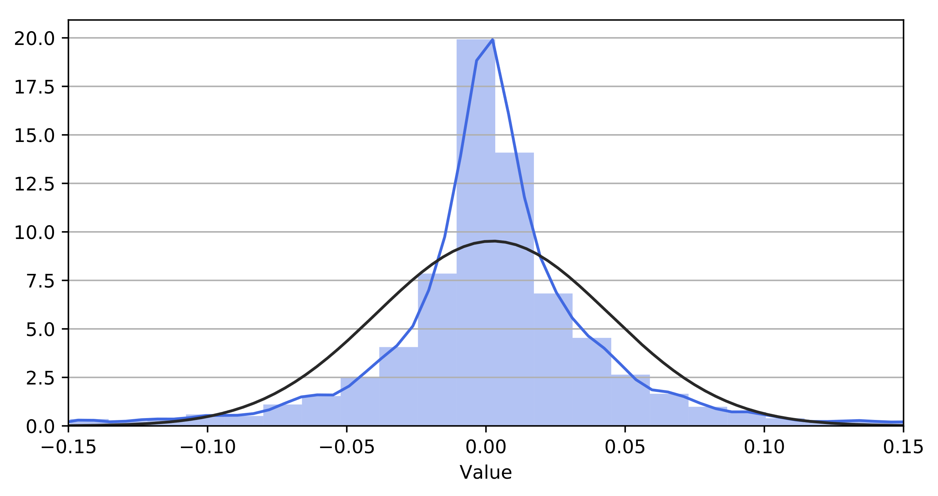

**Figure 12:** Test of data normality

In order to ensure that the fitted curve was basically consistent with the original market trend, we further conducted spearman's correlation coefficient test on the data obtained by geometric Browne, and obtained that the correlation coefficient between the simulated bitcoin curve and the original curve was about 0.7854825. The correlation coefficient between the gold simulation curve and the original curve is about 0.8663413, indicating that the trend is basically consistent.

* **Geometric Brownian motion generates multiple test data**

The parameters required for Brownian motion to produce price trends for gold and Bitcoin are calculated directly from real data, the values of which are listed in Table X,

**Table 6**: Annual and values from 2016 to 2020

|  |  |  |  |  |
| --- | --- | --- | --- | --- |
|  | Gold | | Bitcoin | |
| Year |  |  |  |  |
| 2016 | 0.1255066 | 0.0014333 | 1.9218475 | 0.7320619 |
| 2017 | 0.0867607 | -0.1038957 | 0.3934960 | 0.9459906 |
| 2018 | 0.1113407 | 0.2368993 | 0.4726719 | 0.6886334 |
| 2019 | 0.1863833 | 0.2509477 | 0.0124750 | 0.8175075 |
| 2020 | 0.1555407 | -0.082039821 | 1.5115120 | 0.7871302 |

This table covers the real and of gold and Bitcoin from 2016 to 2020. The and generated by the real values can reflect the impact of major events on the overall price trend of gold and Bitcoin in a year, which can more accurately reflect the changes of the real market. The curve generated by Brownian motion using the data in the table is shown in the figure below,

(a) Bitcoin

(b) Gold

**Figure 13:** Brownian motion generated test data and its decision points

The black lines in the figure 13 represent real market price movements, and the dotted lines in different colors are test curves generated by Brownian motion. Here we simply show a few test curves generated by Brownian motion. In fact, we will generate dozens or even hundreds of curves to test the total return amount, number of decision points and other parameters of our model.

## 6.2 Model performance test模型性能检验

* **Display of test results based on generating curves**

For curves generated by geometric Brownian motion, we still extracted their features and first, and then selected their decision points by random forest algorithm. The generated curves and curve decision points are shown in figure 13（上面那两张）.

Due to the large amount of calculation, the GRU-RNN model and Markowitz Mean-Vaiance model were used to calculate the total return amount when 100 pairs of curves adopted the best trading strategy, and simple statistics and analysis were conducted. The calculation results are shown in the following table，

**Table 7**: Test results presentation

|  |  |  |  |
| --- | --- | --- | --- |
| Total return volume range | Number | Average Bitcoin correlation coefficient | Average Gold correlation coefficient |
| (2700,3000) | 4 | 0.6458965 | 0.7543264 |
| (3000,3300) | 20 | 0.7795451 | 0.8865322 |
| (3300,3600) | 38 | 0.7698458 | 0.8653253 |
| (3600,3900) | 25 | 0.8134784 | 0.8589434 |
| (3900,4200) | 8 | 0.5907567 | 0.8232145 |

In the statistical process, we found that our decision model had a good effect in all the transactions of the prediction curve, basically maintaining an annual return rate of 28%, the lowest about 21.374%, the highest about 33.873%. Much higher than time deposit or other financial management methods. Moreover, we find that the correlation between the simulated curve and the original curve will be reduced to some extent when the return rate is usually higher or lower, but the overall effect is still satisfactory.

In addition, our investment strategy effectively resisted risks, and its final average return rate in 100 pairs of simulated curves was about $3580, and its final average return variance was about 168. This has a good ability to resist risks and gain benefits.

## 6.3 Optimization of trading strategies for different periods针对不同时期的交易策略的优化

* **The calculation of the mean value and variance**

If the GRU-RNN model is needed to make a good prediction of the mean and variance of gold and bitcoin prices in the next 5 days, we need to ensure that there are enough data sets to train the GRU-RNN model.

The results of several experiments showed that GRU-RNN model began to show good accuracy of mean and variance prediction only after a year of data training. In order to improve the improper capital allocation caused by the prediction deviation of GRU-RNN model in the early stage, the variance of gold and bitcoin is similar in a small range, so we adopt the mean and variance of 5 days before the decision point to plan the capital allocation strategy.

* **Buying a time quantifies the choice of timing methods**

If we need to use the random forest algorithm, we also need to ensure that there are enough data sets to train the random forest algorithm. However, at the beginning of the transaction, we did not have enough data to train the random forest, so we considered using other methods to select decision points at the beginning of the transaction.

Three common quantitative timing methods (BB, MACD and RSI) mentioned above were used to select the decision points in the first year. The decision point determination rules of the three common quantitative timing methods have been given in the above common quantitative timing methods.

* **Model verification after optimization**

The geometric Brownian motion is used to generate 100 pairs of curves to calculate the total return when the optimized trading strategy is adopted. The calculation results are shown in the following table.

**Table 8**: Test results presentation

|  |  |
| --- | --- |
| Total return volume range | Number |
| (2700,3000) | 3 |
| (3000,3300) | 26 |
| (3300,3600) | 35 |
| (3600,3900) | 28 |
| (3900,4200) | 8 |

In the statistical process, we found that our optimized trading strategy had a better effect in most of the transactions of the forecast curve, basically maintaining an annualized return rate of 29%, with the lowest about 22.787% and the highest about 34.012%. In the 100 pairs of simulated curves, the final average return is about $3590, and the final average return variance is about 164. All indexes have reached certain optimization. This has a good ability to resist risks and gain benefits.

# Analysis of sensitivity to transaction costs模型对交易成本的敏感程度分析

In the quantitative timing model, we use the random forest model to determine the decision point, and the change of the decision point only depends on the six feature quantities of the past historical data learned by the random forest model, so the change of commission cost will not affect the change of the decision point. However, through the analysis of the decision points, our resource allocation model will not implement the adjustment of asset holding at some of the decision points, and we call the decision points that implement the adjustment of asset holding as the real decision points, and there are about 469 real decision points in five years. By changing the commission cost, observe the change of the real number of decision points, that is, the change of trading strategy. Similarly, changes in the commission costs of gold and bitcoin will inevitably affect the final expected total asset value in the planning model of resource allocation. Therefore, we define the changeable commission cost of bitcoin as α_bitcon and gold as α_gold, and explore the sensitivity of both strategies and results:

* **The influence of parameter changes on the number of real decision points**

First, we controlled or to explore the effect of another value increase or decrease of 0.005% on the number of real decision points. In this way we get the true number of decision points for each of the four cases. In order to specify the change of real decision points, we select the change of commission cost in some time periods to show the change of trading points.

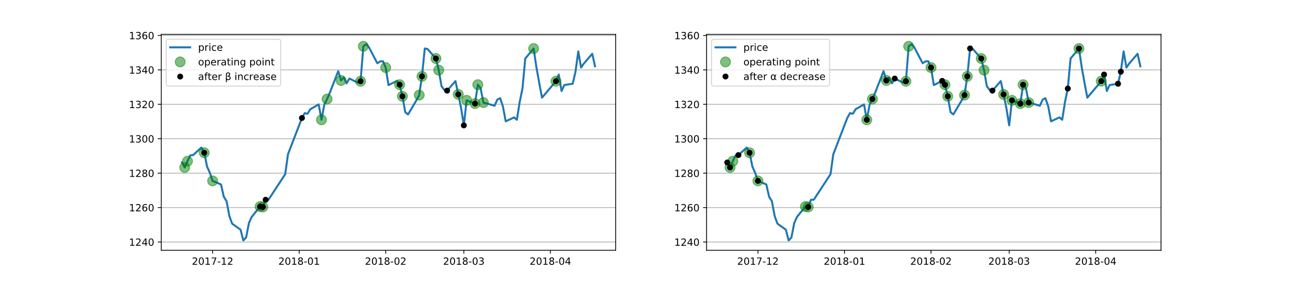

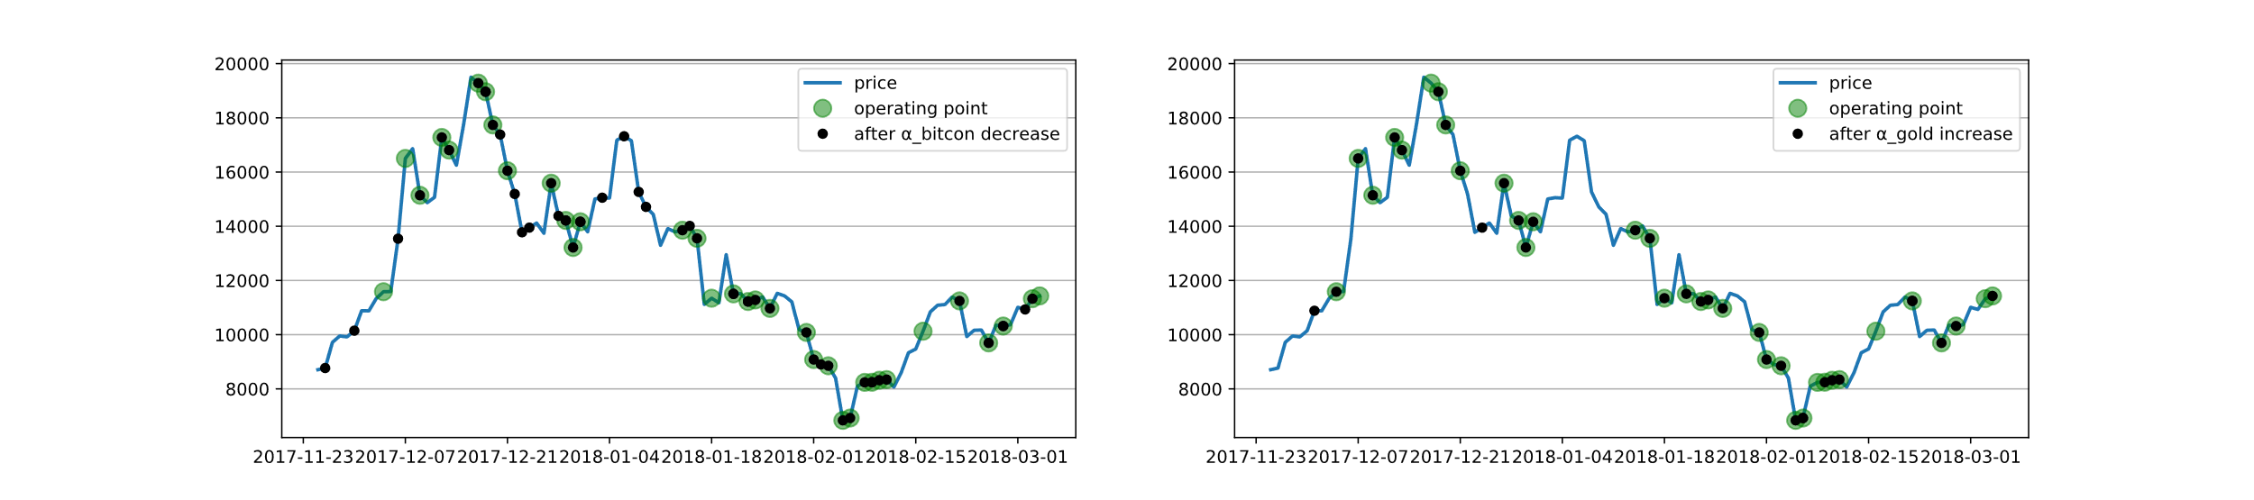

**Figure 17:** The effect of parameter changes on the number of operation points

In the figure, black dots are used to indicate the increase or decrease of real decision points. The following conclusions are found through observation:

* The change in significantly increased or decreased the number of trading points, increasing the number of real decision points from 469 to 511 when it decreased by 0.005%, and some of the trading points changed. When it increases, it also significantly reduces the number of buying decisions.
* The change of parameter has little effect on the number of trading points. When it decreases by 0.005%, the number of real decision points increases from 469 to 486, and only part of the trading points change.

Our analysis:

* Due to its high volatility, the five-year composite annual volatility of bitcoin is about 0.81, so its trading is characterized by high frequency and large volume. Volatility tends to be as high as 10 points, and as we perceive from our portfolio decision model, we tend to be big and fast buyers and sellers. The influence of parameter variation on our model accords with the characteristics of our model.
* Gold has low volatility, with a 6-year comprehensive volatility of 0.16. Therefore, in our model, it is often regarded as an asset that avoids risks and has certain income, so its trading frequency is low and the trading volume is small, and the transaction cost itself is not high. Therefore, the increase or decrease of transaction rate has little influence on our model decision.
* The influence of parameter changes on the final trading results

Quantitative trading is a complex process. In the process of exploring the influence of and arameters on the final trading results, we tried to change the two parameters and listed part of the final trading results in the following table,

# Strength and weakness

## 8.1 Strengths

* Random forest conforms to the thinking logic of investors in actual investment, so the decision tree model has strong scalability. We can increase or decrease and change technical indicators to create personalized trading strategies.
* The method of selecting decision points by random forest greatly reduces the amount of model computation and the workload of traders. Instead of daily trading with a high rate of return, you plan to allocate money only on dates with decision points.
* Our model takes into account the interaction with traders, so trading strategies can be planned according to the range of risks traders can bear.
* Use geometric Brownian motion to generate multiple test data sets to test and analyze model parameters to obtain the optimal value, and the parameter optimization degree is higher.
* Our resource group and allocation model weigh the relationship between return rate and risk, so as to ensure high return with low risk.

## 8.2 Weakness

* The problem of over-fitting may occur in the classification of random forest with large noise.
* Based on the prediction and point selection model of RNN network and random forest algorithm, there is a lot of data to learn, a relatively large operation process, and a long time to program and run the program
* Risk is not rated, so investors can not necessarily quantify the maximum risk they are willing to take

# Conclusion

In this paper, we systematically study influence of music through networks and our results: First, we construct music influence network, derive the influence score based on four network met

# Document to the ICM Society（letter）

Dear ICM Society:

随着电子信息技术地改革和不断发展，机器学习算法地不断迭代。量化交易已经成为越来越多交易员的选择。我们很高兴能够受到您的邀请，协助您来开发模型去揭开交易市场的神秘面纱，掌握交易市场的规律，了解如何配置资产以达到高收益和低风险的目的。此篇memorandum意在简要阐明我们的观点和见解，希望对您有所帮助。      首先，我们基于一些现有的金融学知识为您提取了一些能够反应黄金或者比特币价格变化的特征参数，例如  
  
等等，它们的具体含义和作用已在上文中为您介绍。但是金融市场千变万化，即便我们了解了这些特征我们也很难做出决策。所以我们使用随机森林对决策日期进行了量化交易择时。同时我们总结一部分交易择时策略给您。      为了在组合投资中综合考虑风险，收益，市场规则等因素我们基于Markowitz投资策略为核心建立了一个多目标规划模型。在该模型中我们以最大化每一次交易收益，最小化每一次交易风险为目标，以市场交易规则为限制条件。为得到该模型所需的期望和方差我们还又搭建了一个两层共260个记忆体的GRU-RNN网络来对未来指标进行预测。      不负您的所托，我们所建立的  模型经过几何布朗运动的模拟检验，经过交易成本参数的敏感度检验。其的年化收益能够较为平稳地维持在  
  
左右。通过模型良好的交易策略，实现本金从一开始的1000美元到5年后的3400美元的变化。      我们非常感谢能有这个机会帮助您通过建立模型来了解金融市场发展的规律，探究资产配置的奥秘。我们希望我们的模型可以在您未来的交易中起到作用。期待您与我们的下一次联系。下图大致展示了我们模型的大体框架。

Sincerely yours,

Team 2208251

# Reference

[1] Liu Libin. RSI index to judge price trend [J]. Public Financial Adviser,2008(09):52-53.

[2] Yan Hongmei. Analysis on the application of RSI in overbought and oversold type [J]. China Securities and Futures,2013(08):260+262.

[3] Zhou X. The application of Bren band trend breaking strategy in digital currency market [D]. Zhejiang industry and commerce university, 2021. DOI: 10.27462 /, dc nki. GHZHC. 2021.000281.

[4] Jiang G Y. Research on optimal parameters of MACD index -- a technical strategy of quantitative investment [D]. Jilin University of Finance and Economics,2018.

[5] Ye Bo. Trading Part FOUR: Gann's Rule & Bollingband Trading System [J]. Public Financial Adviser,2008(02):70-71.

[6] Yan Zhengxu, Qin Chao, Song Gang. Stock price Prediction based on Pearson Feature Selection in Stochastic Forest Model [J]. Computer Engineering and Applications, 2021,57(15):286-296.

[7] Chen jia. RNN neural network application in the stock index prediction research [D]. Tianjin university of science and technology, 2019. The DOI: 10.27359 /, dc nki. Gtqgu. 2019.000459.

[8] Liu Yang, Zhang Yue, Zhu Lifang. Real estate prices based on geometric Brownian motion simulation prediction [J]. Journal of statistics and decision, 2018, (9) : 86-89. The DOI: 10.13546 / j.carol carroll nki tjyjc. 2018.09.020.